In this lab, your goal is to generate a personalized greeting file locally using Terraform without using any cloud provider.
You will use the local_file resource to create a file with a custom message.

Objectives
- Accept input from two variables:
- username – the person to greet ("user123")
- message – a custom welcome message ("Welcome to Terraform training!")
- Use these inputs to generate a greeting message with this exact format:
- Hello, <username>! <message>!
- The file name should be: welcome_<username>.txt
For example: welcome_user123.txt
- The contents of the file should be:
- Hello, user123! Welcome to Terraform training!

Files
You must work in the main.tf, variables.tf, and terraform.tfvars files provided.
- variables.tf: Declare input variables like username and message.
- terraform.tfvars: Assign actual values to those variables.
- main.tf: Use the local_file resource to create a file named welcome_<username>.txt with the content:
"Hello, <username>! <message>!"

What You Will Learn
- How to define and use variables in Terraform
- How to interpolate values in strings
- How to use the local_file resource to create local files
- How to go through the complete Terraform workflow:
  - terraform init
  - terraform plan
  - terraform apply

Lab :
Configure the variables in variables.tf , assign values to the variables using terraform.tfvars file, configure the resources in the main.tf file as shown below :
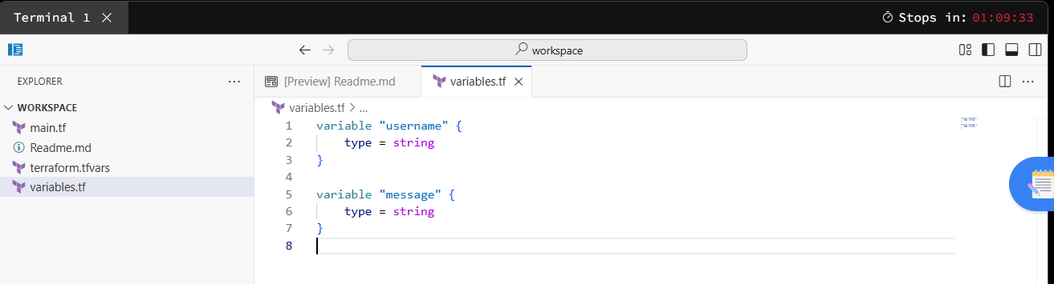

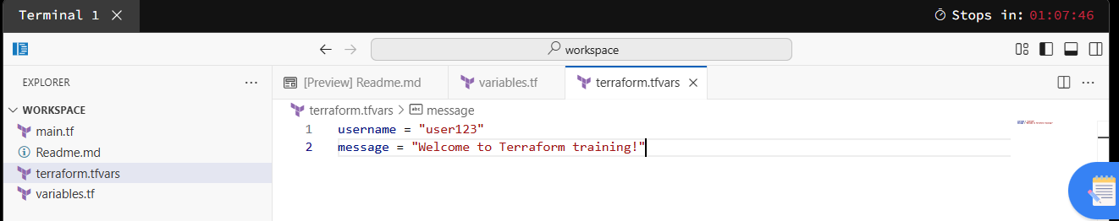

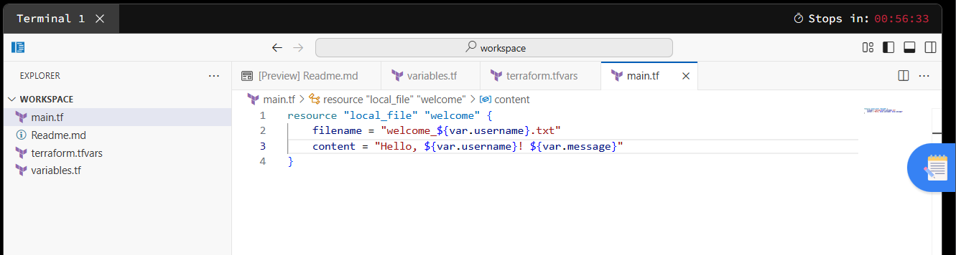

terraform init :

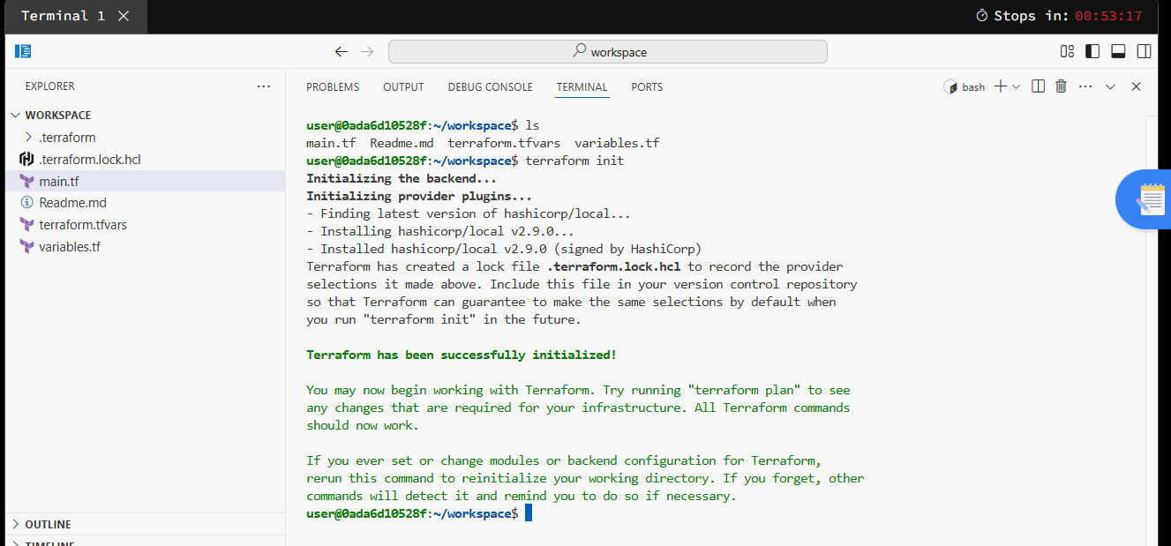

terraform plan :
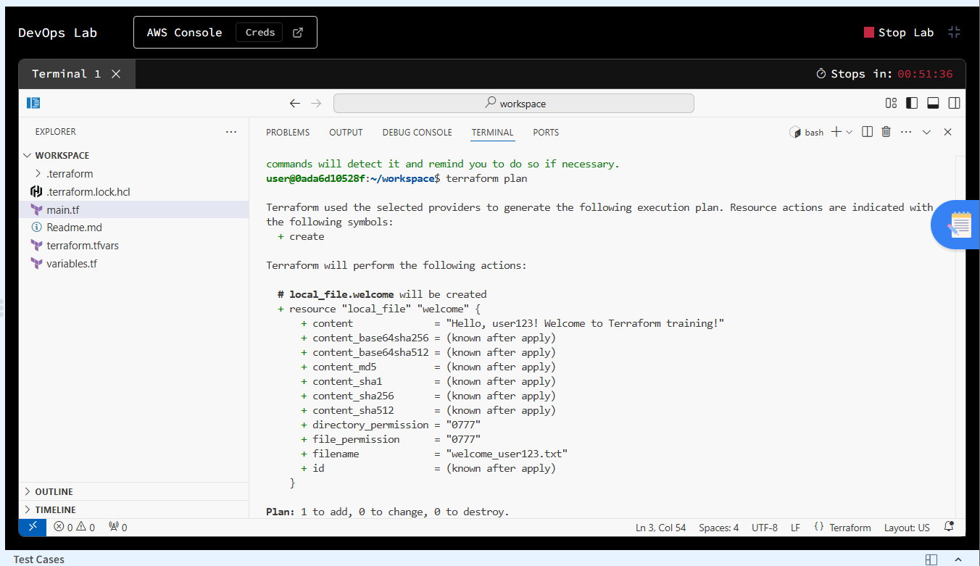

terraform apply :

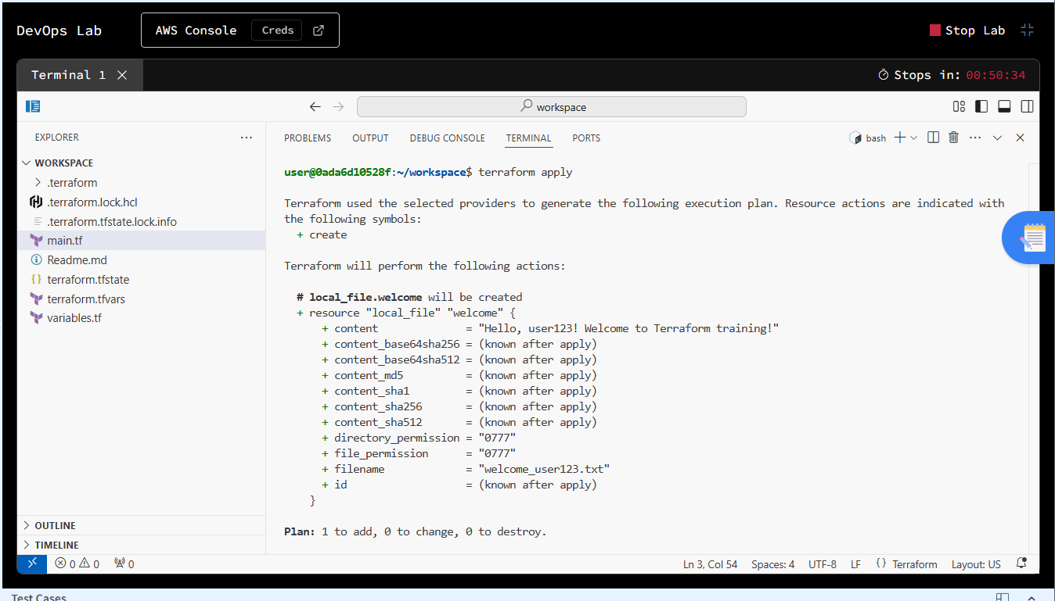

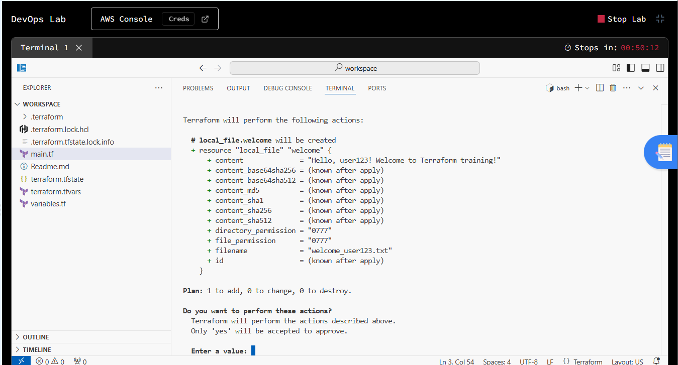

after running the terraform apply you can see the file welcome_user123 file is created.

